XMEDIUS FAX WEB GUIDE

Contents
• Logging Into Xmedius Cloud 1
• Xmedius Cloud Navigation 1
• Sending A Fax 2
• Receiving Department Faxes 3
• Fax By Email 4

Logging Into Xmedius Cloud
- You should receive a welcome email from Xmedius Cloud, asking you to register for the site and create a password.
- To login, navigate to http://portal.xmedius.com/sinclair
- Login with your Sinclair network username, and the password you set previously.

Xmedius Cloud Navigation

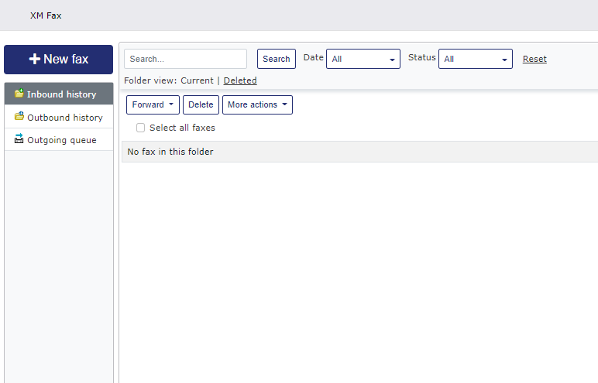
2
3
1
1
  - Inbound History - Once logged in, you will be brought to the “Inbound history” tab. This is where you will see your department’s received faxes if you are setup to receive them. From here you can download the fax, forward it to another user, or print it out
  - Outbound History – This is where you can see all your outgoing faxes coming sent by you. If you setup to receive incoming department faxes via email, you will also see all of the department’s outgoing faxes.
  - Outgoing Queue – This is where you can see the status of new faxes that you have created via Xmedius Cloud.

Sending A Fax

  - Click on the “New Fax” Button.
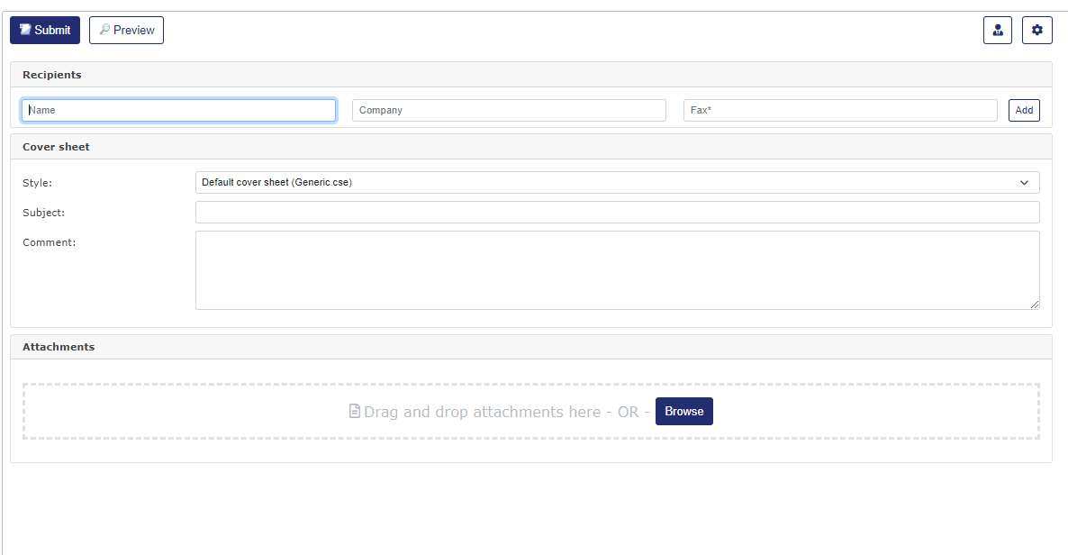

  - The only required field is the Fax number. You do not need to put any special preceding numbers. It must include the area code (i.e. 937-512-2000).
  - There is a generic cover sheet that will accompany your fax. It will include your information and your department’s fax #. You can add a subject or comments that will show up on the cover sheet that as well.
  - Under the Attachments section, you can click “Browse” and upload a document to add to the fax. Alternatively, you can drag and drop to the attachment box.
  - Once finished, you can preview the fax. If you are happy with how it looks, click on “Submit”.
  - Once submitted, you can return to the “Outgoing queue” tab and check the status. Once it has completed, you will be able to see it in the “Outbound history” tab
  - You will also receive an email confirmation letting you know that the fax was delivered.

Receiving Department Faxes
  - When your department receives a fax, at your department leader’s discretion the fax will print out on your department’s copier, or selected users will receive an email when a fax is received.
  - Your manager can decide whether they want that email to contain a copy of the faxed document(s) or not.
  - If the fax email attachment is enabled for your department, then you can download/save the faxed document(s) straight from the email.
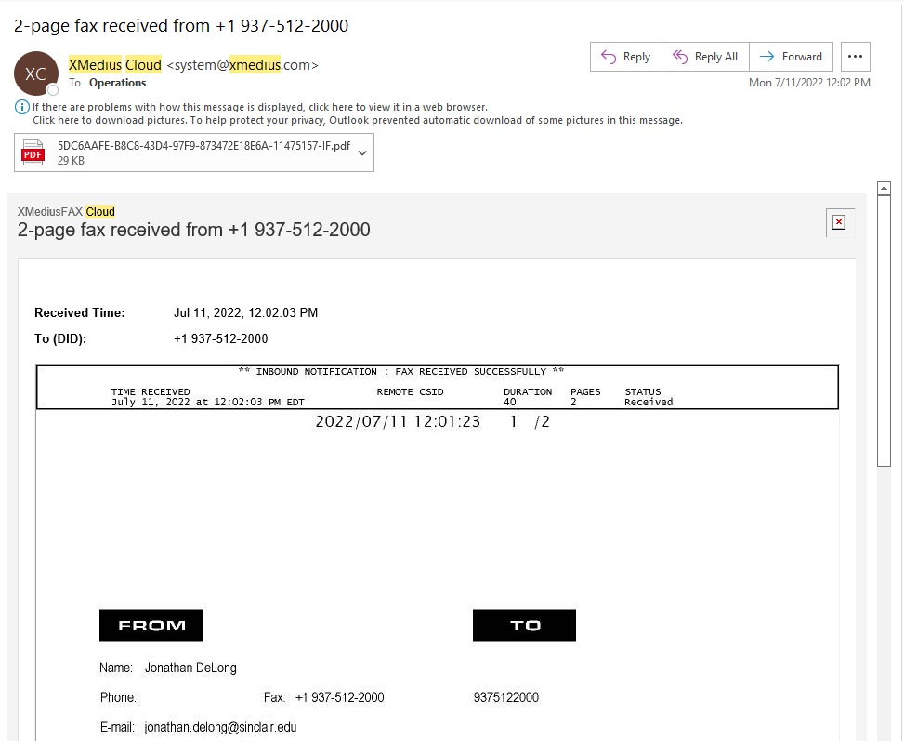

  - If your manager chooses not to have faxes come through as an attachment, then you will need to log into XMedius Cloud to view the fax. Again, this is only if your department chooses not to have incoming faxes print out on the copier.

Fax By Email
  - With Xmedius Cloud, you can avoid logging in to Xmedius, and simply send a fax from your Sinclair email account.
  - All you need to do is send an email to faxnumber@xmedius.com (1-800-512-2000@xmedius.com). This email must come from your Sinclair email account. There is no need to add a “9” at the beginning.
  - You will also receive a fax confirmation email letting you know that the fax was delivered.

